**Azure Case study—** 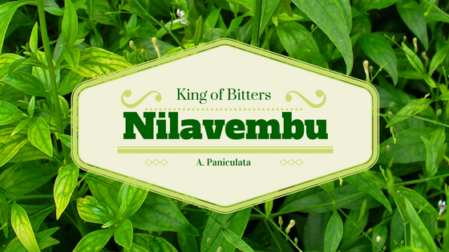

Nilavembu Herbs provides a safer alternative to modern medicine wherever possible and to offer simple, effective and safe remedies for common problems. spreads awareness about the medicinal uses of these natural and safe herbs all over the world and to make it easily available through their online store for all those who want to enjoy its benefits

Nilavembu Herbs requires

* A low-cost solution based on demand of dynamic business conditions.
* As the business expands across EastUS and SEA, they would like to have their DataCenter virtualised using cloud computing.
* Critical Data should be made available in case of disaster

**Requirement for SEA region-**

* 2 web servers with 99.95% high availability
* These web services has to be utilised with proper balance with client affinity with Public IP
* Selected web servers should be reachable via RDP from internet
* A jump port should accessible from internet to upload contents to web servers.
* Protect web server traffic restricted to allowed based on ip addresses which will be updated as warranted
* Enable backup for WebServers
* Have alert generated in case of 80% above cpu usage

**Requirement for EUS region-**

* EastUS server (Server11) should be accessible from internet via public IP
* Establish secure Connection to SEA-EUS Azure sites
* All servers should be reachable with internal ip addresses

**Storage requirement-**

* EUS based resources should provide data resiliency in case of azure datacentre failure.
* The storage should be accessible by applications with secure access. provide access urls and keys.
* Sales manager should access his resource from windows explorer.
* SEA data resources must provide high resiliency in case of even multiple azure data center failures

**Resource management-**

* Create Vmadmin user who can manage all VM in the subscription
* Create Backup_admin user who can manage backup only in EUS servers in EURG

**List of Activities-**

|  |  |  |
| --- | --- | --- |
| **Serial number** | **Activity** | **Method** |
| **1** | **Resource group for SEA** | **PowerShell** |
| **2** | **Availability set** | **PowerShell** |
| **3** | **vNet + Subnet set up** | **PowerShell** |
| **4** | **Security rules** | **PowerShell** |
| **5** | **NSG for webservers** | **PowerShell** |
| **6** | **vNet configuration** | **PowerShell** |
| **7** | **Deployment of 2 VMs** | **PowerShell** |
| **8** | **Web-server extension on webservers** | **PowerShell** |
| **9** | **Load Balancer configuration** | **PowerShell** |
| **10** | **Jump server** | **Azure console** |
| **11** | **NSG rules for Jump server** | **Azure console** |
| **12** | **Backup for Jump servers** | **Azure console** |
| **13** | **CPU alert set up** | **Azure console** |
| **14** | **East US RG creation** | **CLI** |
| **15** | **East US VM creation** | **CLI** |
| **16** | **East US Port set up** | **CLI** |
| **17** | **US RG creation** | **Terraform** |
| **18** | **US VM creation** | **Terraform** |
| **19** | **vNet peering** | **Azure console** |
| **20** | **SEA Storage account creation** | **PowerShell** |
| **21** | **EUS Storage account creation** | **PowerShell** |
| **22** | **US Storage account creation** | **Terraform** |
| **23** | **US Share file creation** | **Terraform** |
| **24** | **Vmadmin user creation** | **Azure console** |
| **25** | **Vmadmin RBAC** | **Azure console** |
| **26** | **Backup_admin creation** | **Azure console** |
| **27** | **Backup_admin RBAC** | **Azure console** |